# NSS UNIT 10

The National Service Scheme is an Indian government-sponsored public service program conducted by the Ministry of Youth Affairs and Sports. It was launched in 1969, during the birth centenary year of Mahatma Gandhi, with the primary objective of involving the youth of India in constructive social work. The NSS aims to develop the personality of students through community service and to instill in them a sense of social responsibility.

The National Service Scheme at Payyanur College has three units, specifically Units 10, 11, and 95. The Unit 10 has won Best Unit award in the district level and State level.

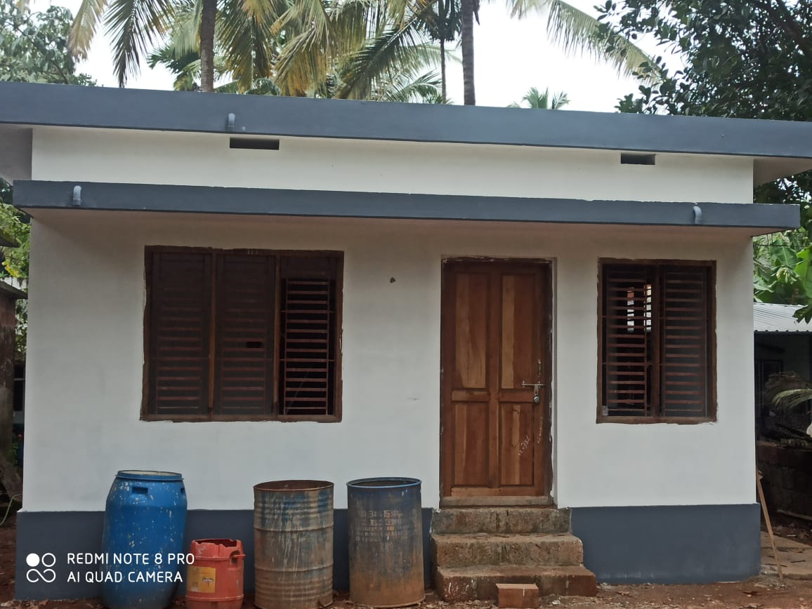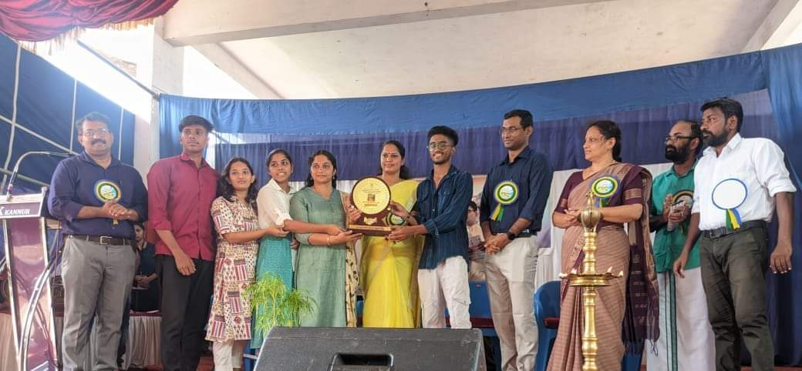The NSS unit of Payannur College has undertaken a variety of impactful activities aimed at making a difference in the lives of people in their adopted village, school, and for the differently-abled. The unit has been actively involved in providing support and resources to differently-abled individuals, ensuring they have access to necessary facilities and a supportive community. In their adopted village, the volunteers have worked tirelessly to improve living conditions through various development projects, including sanitation drives and awareness campaigns. The unit also extends its efforts to an adopted school, where they focus on improving educational resources and infrastructure, creating a conducive learning environment for the students. Additionally, the NSS unit is deeply committed to palliative care, offering emotional and physical support to those in need, ensuring dignity and comfort in their most vulnerable times. These initiatives reflect the unit's dedication to community service and social responsibility, making a lasting impact on the lives they touch.

SAHACHARI AWARD

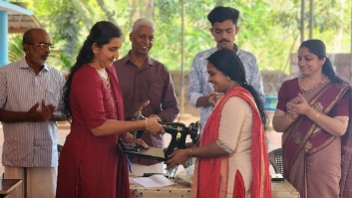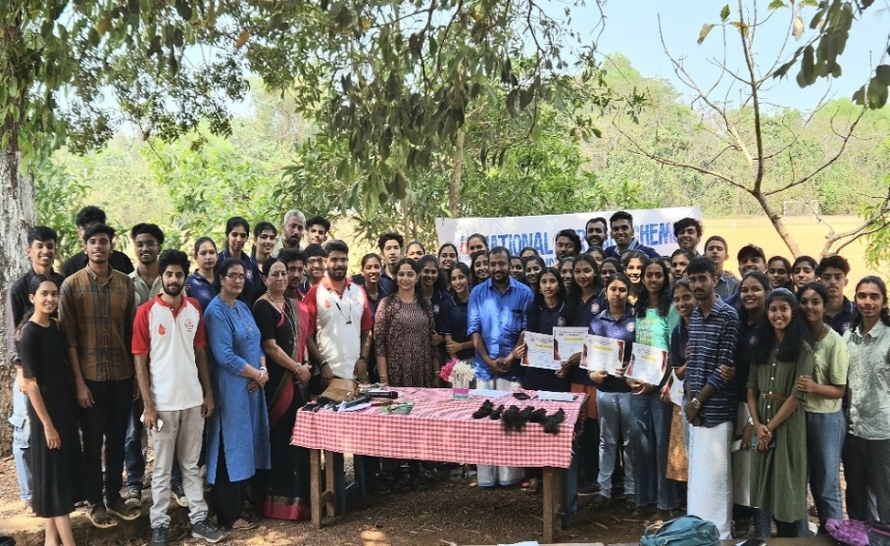

HAIR DONATION SEWING MACHINE DONATION

**FLY CAMP**

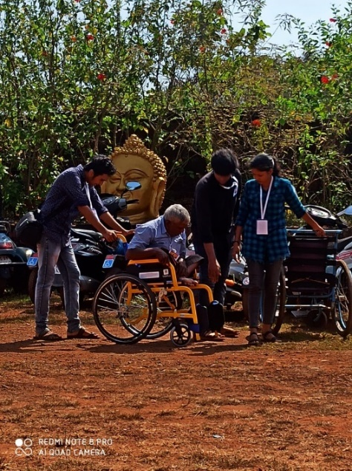

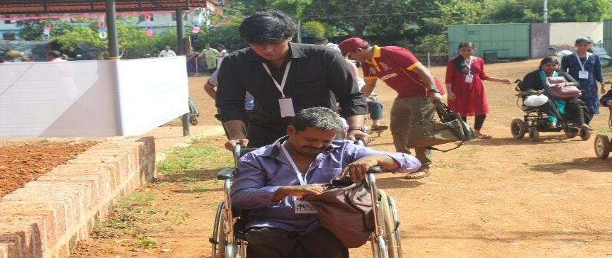

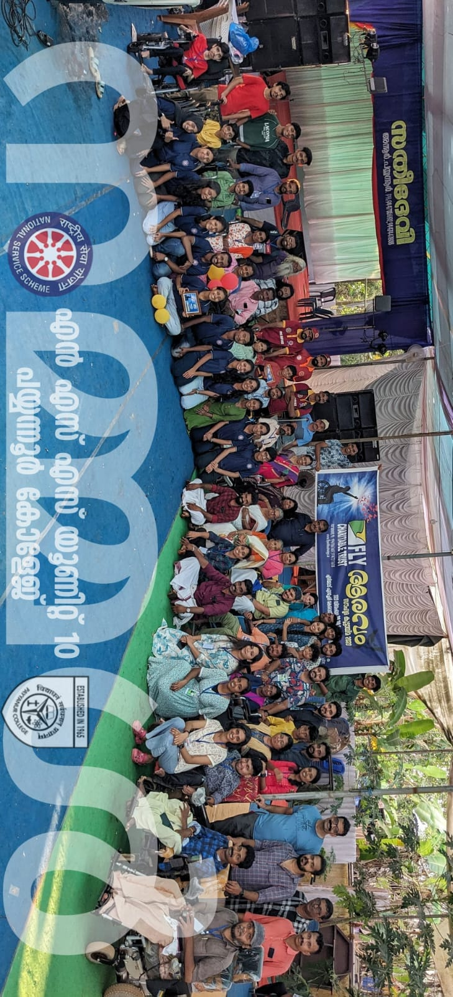

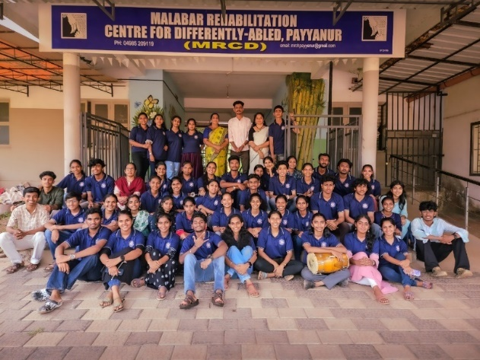

MRCD SCHOOL VISIT

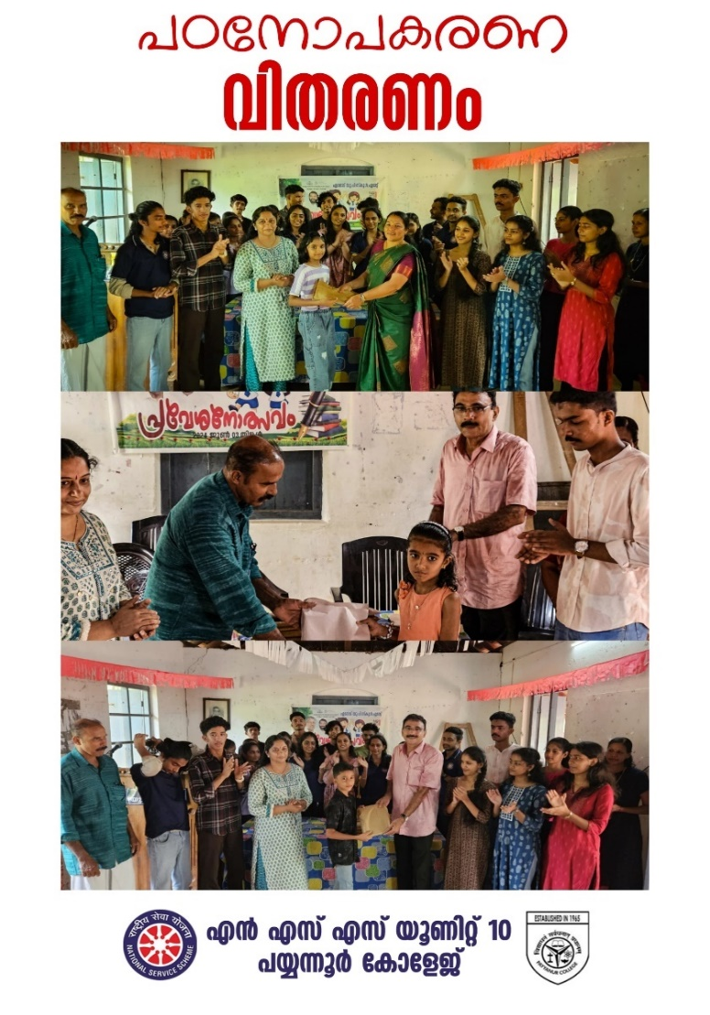

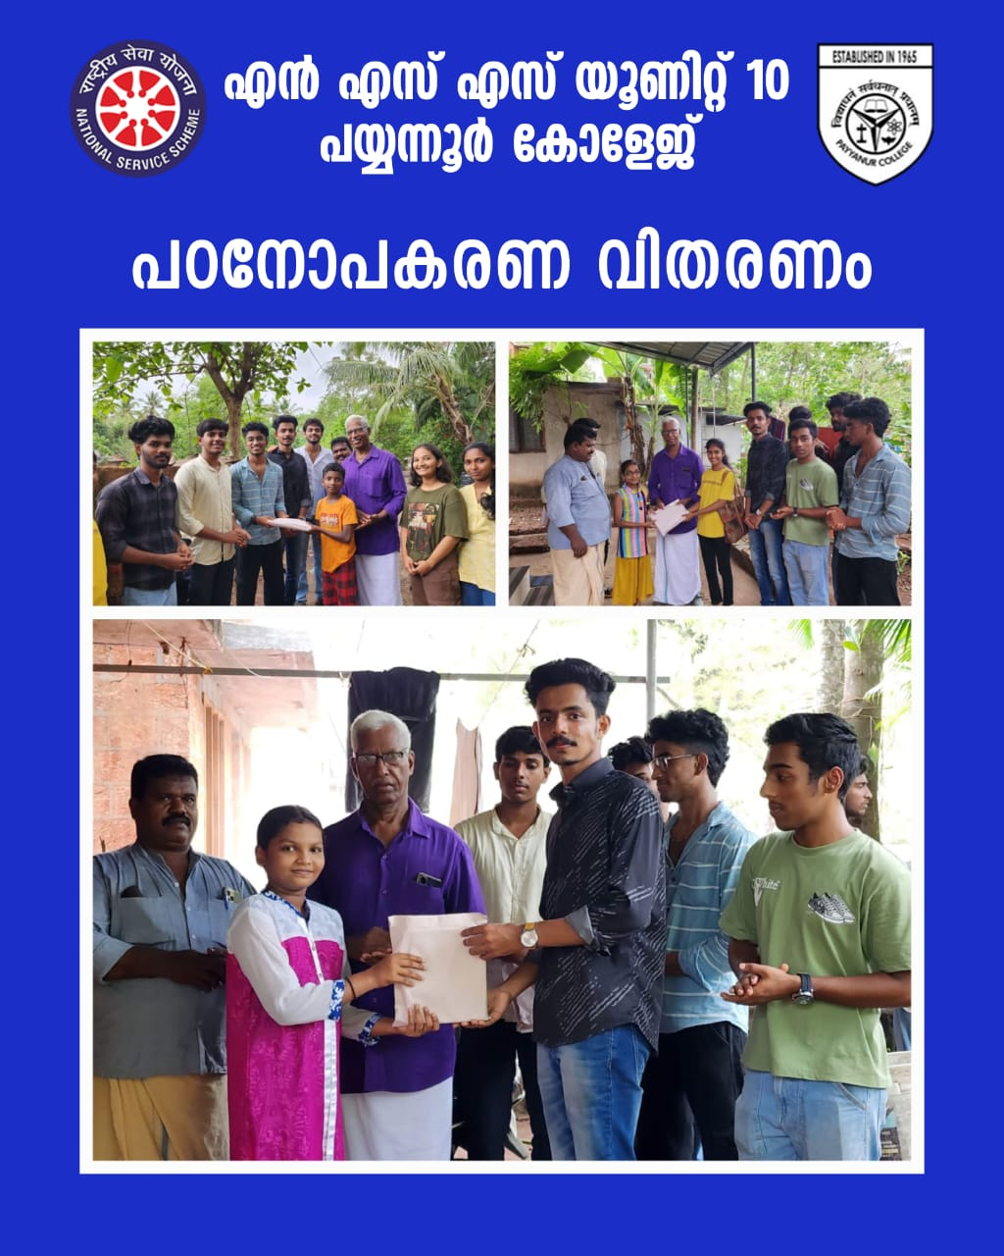

PROGRAMMES AT EDANAD U P SCHOOL

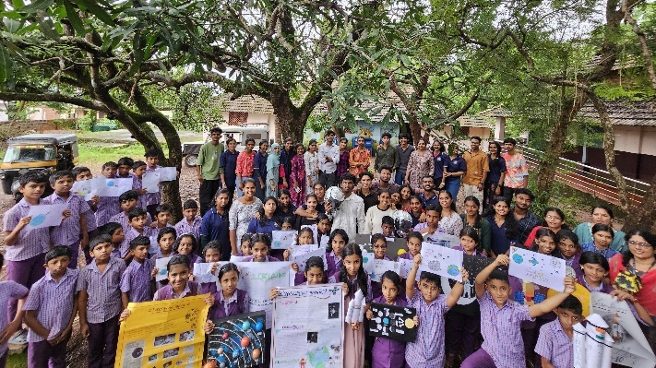

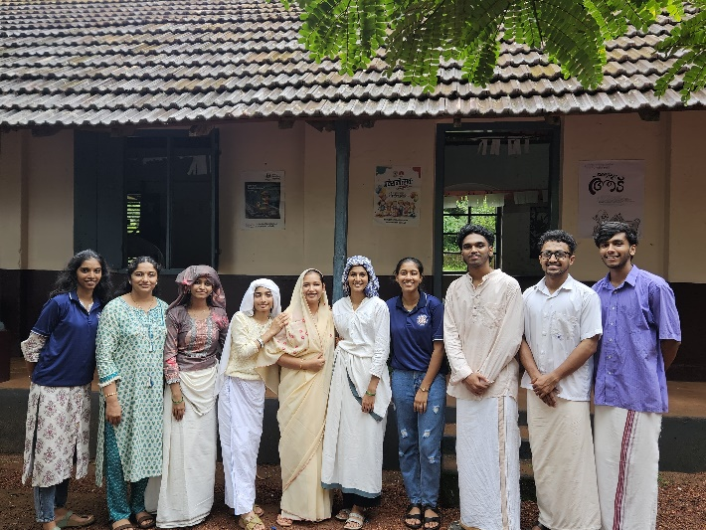

BLOOD DONATION CAMP

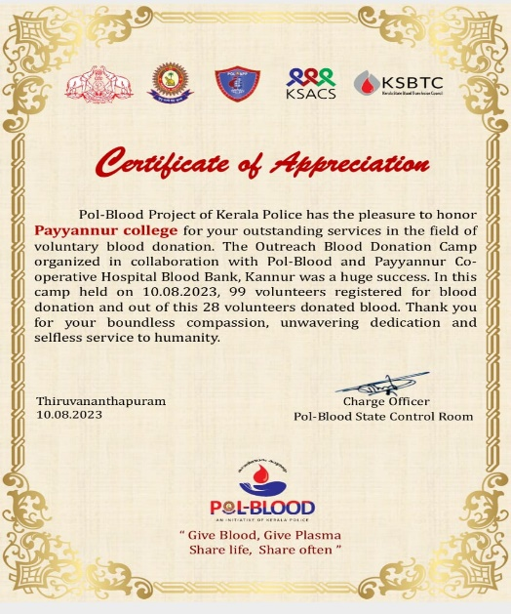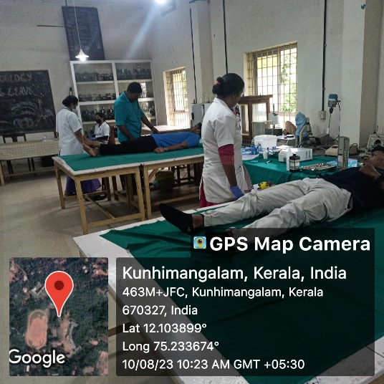

STEM CELL DONATION CAMP

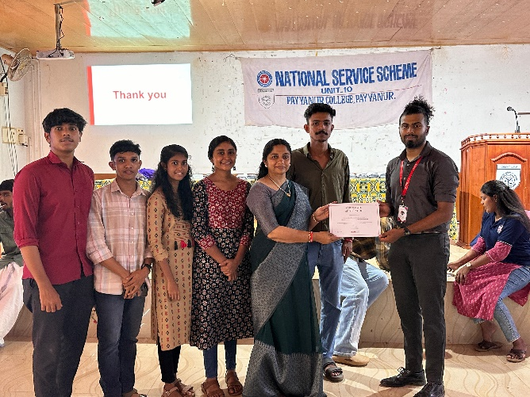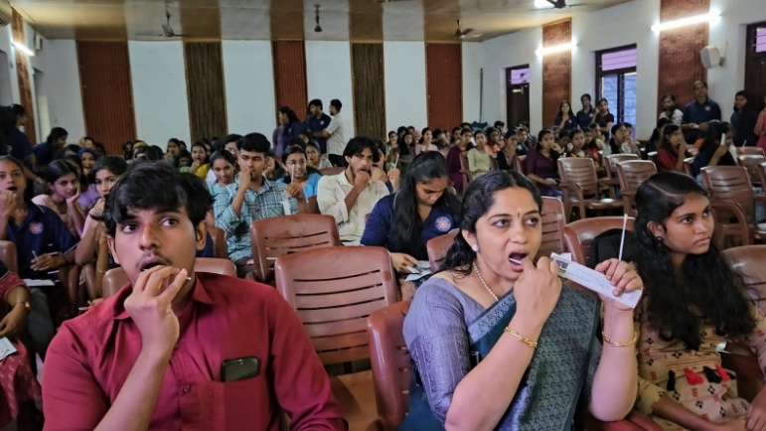

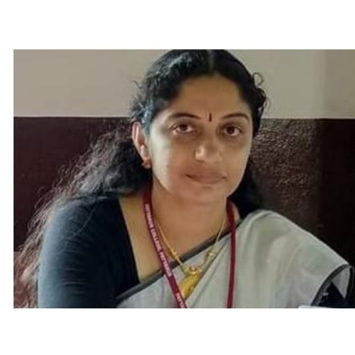PROGRAMME OFFICER VOLUNTEER SECRETARY

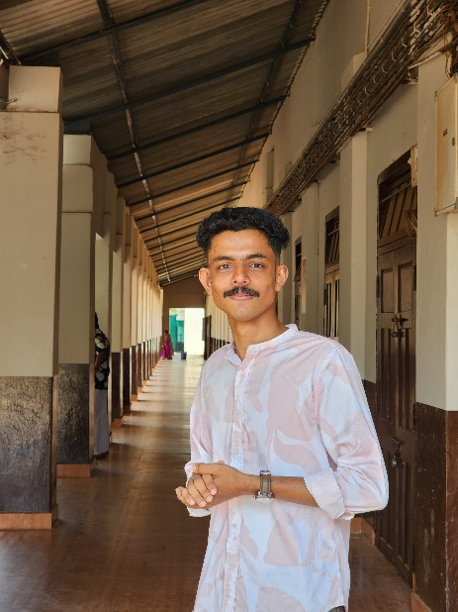

­­

Dr.Surekha T V

Asst.Professor

Dept of Hindi Vishnu C V

Payyannur College BCOM