**MOVIE MANIA**

Movie Mania, a registered film club of Payyanur College, Payyanur, was founded in 1985-86 by Dr. T. Pavithran and Dr. K.C. Muraleedharan, with student coordinators like Mr. M.V. Gireeshkumar and Mr. P. Premachandran. The club began by screening classic films in classrooms using hired projectors. Before the establishment of the club, screenings were conducted by Prof. John C. Jacob and a few others, laying the foundation for Movie Mania.

Both teachers and students have long participated in major film festivals such as IFFI and IFFK. The establishment of the Visual Media Room in the late 90s enabled the club to conduct college-level film festivals and exhibitions. The college collaborates with regional film clubs, engages in various activities, and subscribes to film journals. Films have become part of the curriculum, topics for student projects, and UGC minor projects.

Currently, the college offers Open Courses and Certificate Courses in Film and Media Studies. Many directors, cinematographers, scriptwriters, lyricists, actors, critics, and film society activists have emerged during these years. Recently, Payyanur College has become a popular location for film shoots. Dr. A.C. Sreehari is presently the staff coordinator of Movie Mania.

**Teacher-in-charge**:

Dr AC Sreehari

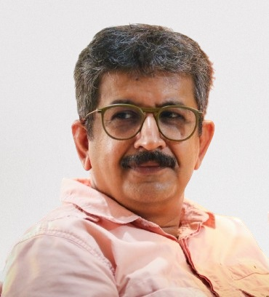

**Student-in-charge:**

Nived Narayan



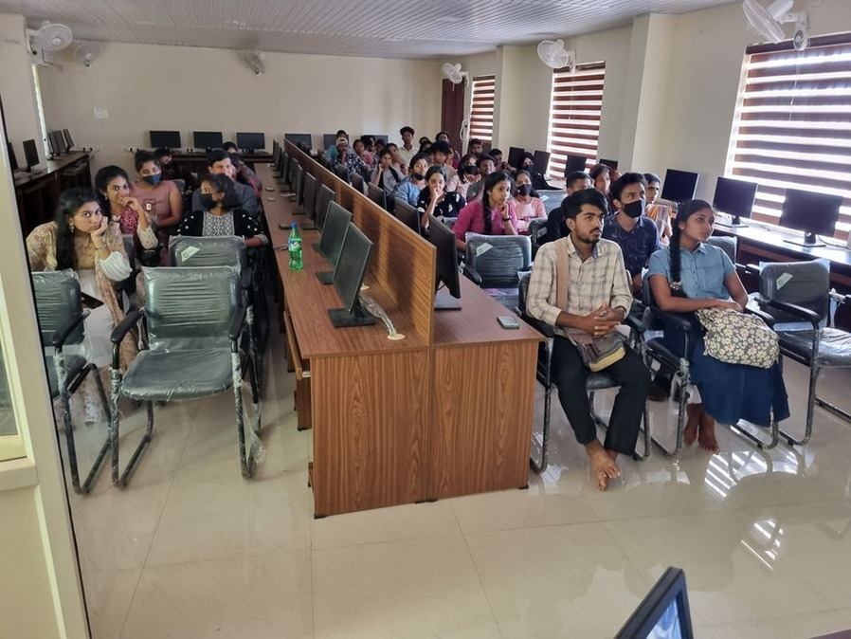

Short Film Screening

