**ENGLISH CLUB**

The English Club of Payyanur College is a dynamic and inclusive student-centric platform that fosters holistic development, creativity, and critical thinking among its members beyond the confines of the academic curriculum. With a focus on empowering students to succeed in today's fast-paced world, the club offers a diverse range of activities and initiatives that cater to various interests and talents.

The club provides a platform for students to enhance their language skills, critical thinking, and creativity, while fostering a culture of intellectual curiosity, debate, and discussion. It encourages them to explore their interests and passions beyond academics, developing essential life skills such as communication, teamwork, and leadership.

Activities include vibrant discussions and debates on contemporary topics, literature, and social issues, as well as writing workshops, poetry recitals, and creative writing sessions. The club also hosts quiz programs, literary competitions, and language games, and observes national and international days like World Literacy Day and World Poetry Day.

The club celebrates major literary events, such as book launches and author talks, and collaborates with other departments and clubs to promote interdisciplinary learning. Led by enthusiastic, energetic, and self-motivated student coordinators, the club is open to all students of Payyanur College, regardless of department or semester.

Through its activities, the English Club has become an integral part of the department, providing a sense of community and belonging among students. It has helped students develop essential skills, such as critical thinking, communication, and teamwork, and has fostered a culture of intellectual curiosity and creativity, preparing students for success in their academic and professional pursuits.

Teacher-in-charge:

Mr Mani KP



Student-in-charge:

Malavika T



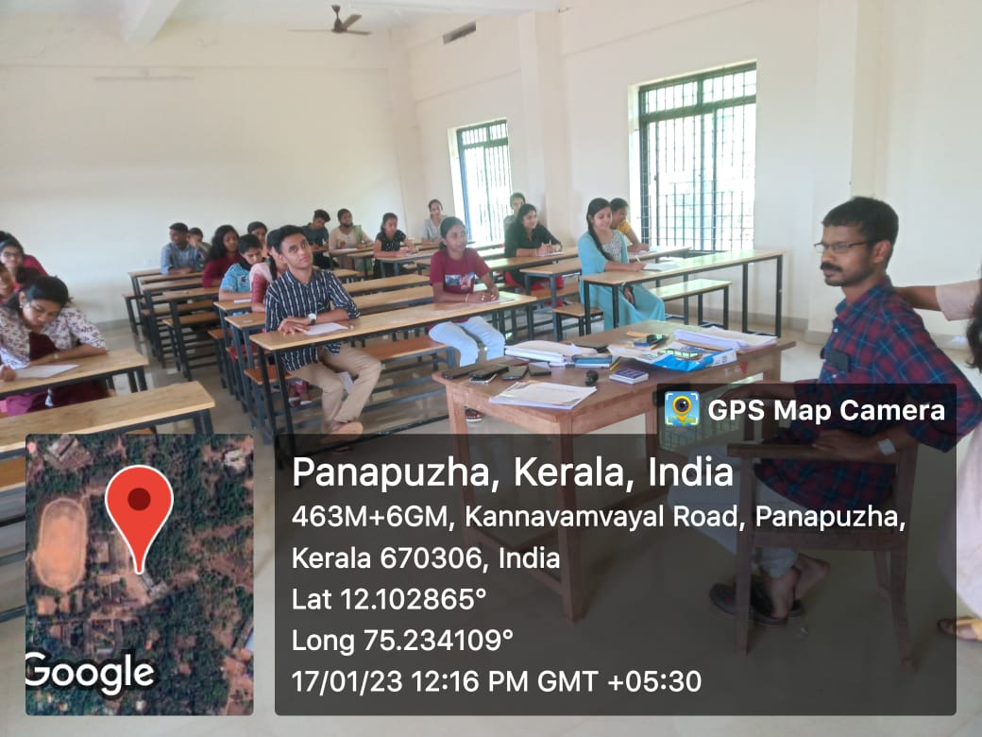

“22 Poems in 2022” programme