**Welcome to the Physics Club!**

Physics Club serves as a platform for students who are passionate about physics to explore, discuss, and deepen their understanding of the subject beyond the classroom. The club often fosters a community where students can share ideas, stay updated on the latest developments in the field, and even contribute to outreach activities to inspire younger students. Ultimately, a Physics Club enhances the academic experience by promoting curiosity, critical thinking, and collaborative learning among students interested in physics.

**Our club is dedicated to:**

- Exploring the wonders of physics through experiments and discussions

- Discovering new concepts and applications

- Innovating solutions to real-world problems

- Support students in their academic and professional pursuits in physics

- Build a network of physics enthusiasts who can learn from and inspire each other

**Our Activities:**

- Hands-on experiments and projects, such as bridge building and robotics

- Guest lectures and workshops by experts in the field

- Participation in physics competitions and Olympiads

- Outreach and education programs to share the excitement of physics with the wider community

-Commemorate the important days pertaining to science

Join Us!

Whether you're a physics major or just curious about the subject, we invite you to join our club and be a part of this exciting journey of discovery and exploration!

Teacher in charge: Dr. Preethi Rajan M.K

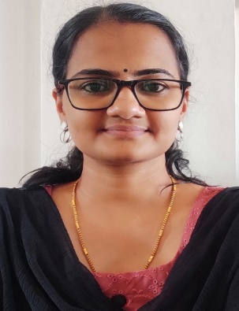

Student in charge: Roopak .V.P, II DC Physics



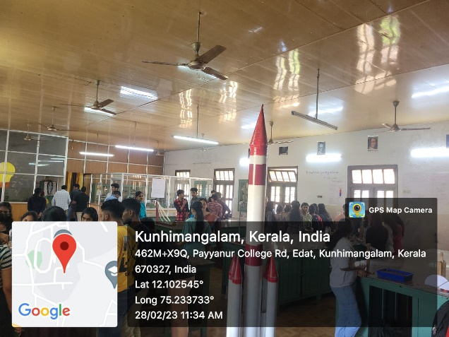

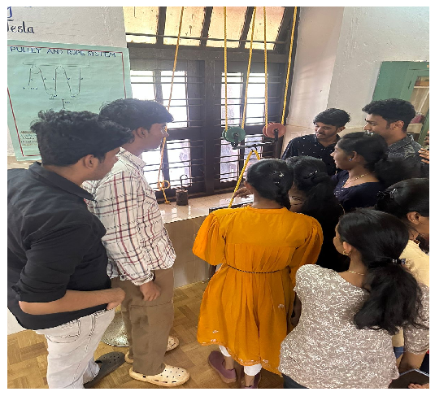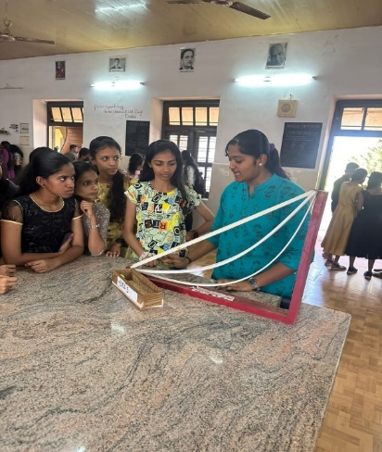

“THARANGAM 2023”-SCIENCE EXHIBITION