**DEPARTMENT OF MATHEMATICS**

**MATHS CLUB**

Maths Club, Department of Mathematics, Payyanur College, Payyanur was founded in 2002 by Prof. Vinod Kumar P with student coordinator Umesh P. By creating a community of like-minded people who are passionate about math, math club gives young minds a platform to explore mathematics outside of the classroom.

**Objectives:**

* Promote mathematical curiosity and enthusiasm.
* Encourage problem-solving and critical thinking.
* Provide a platform for peer learning and discussion.
* Explore real-world applications and interdisciplinary connections.
* Organize guest lectures, workshops, math fairs and social events.

**Activities:**

* Regular meetings to discuss math topics, solve problems and engage in math related games.
* Lectures of invited professors and researchers to share insights.
* Math competitions and puzzle-solving events.
* Math- themed events.
* Math workshops and exhibitions for local schools.
* Celebrate important National and international days.

The membership is open to all students of mathematics department.

 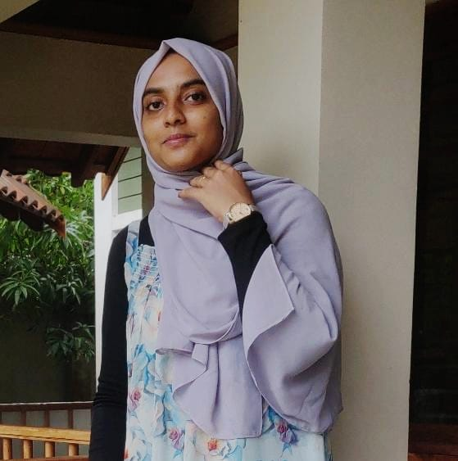

Teacher coordinator: Jijina K Student coordinator: C K Thamanna

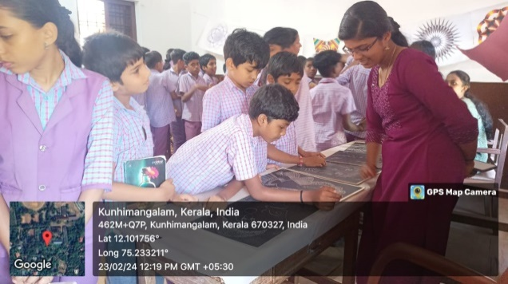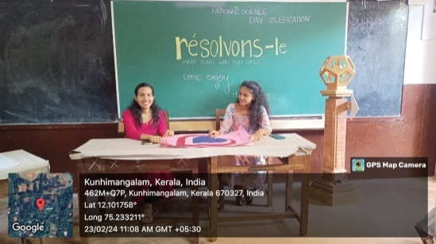**‘RESOLVENOS-LE’ National Science Day Celebration-Math Expo with fun games**

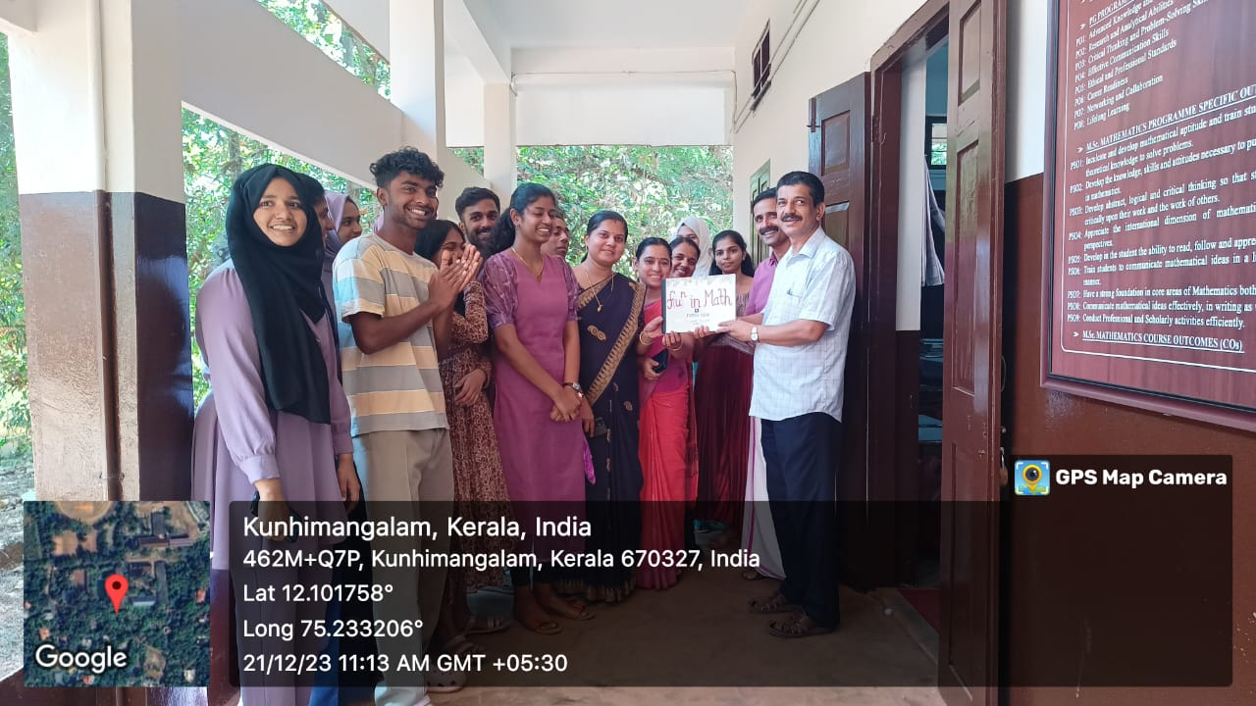

**Releasing of manuscript magazine ‘ $f{\left(U\right)}^{N}$ IN MATH’**

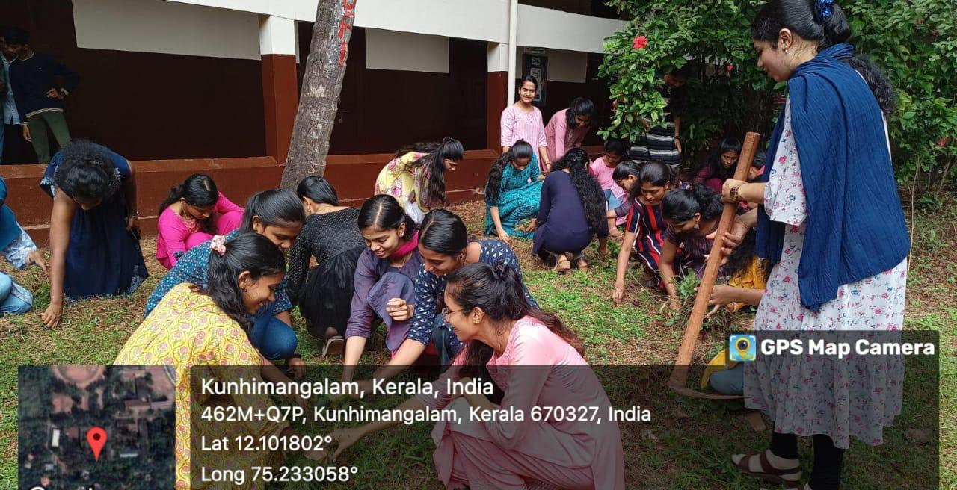

**‘PLANT A TREE AND GROW TOGETHER’-An initiative to make department garden**