**BOTANY CLUB**

**The Botany Club** was founded in the early days as a student recreational gathering under the **Department of Botany.** The Club plays an important role in enhancing the overall student experience by focusing on welfare measures, recreation, field visits, and other co-curricular activities. Through its diverse initiatives, the club not only nurtures a love for botany but also promotes the well-being, personal growth, and academic success of its members. Club is open to all the students of Botany Department and regular meetings and discussions are conducted among the members for the smooth conduct of the club activities.

**Student recreation** is an integral part of the Botany Club’s agenda. The club organizes a variety of recreational activities that cater to diverse interests. **Gardening sessions** are a popular choice, allowing students to engage in hands-on activities such as planting, pruning, and maintaining the club’s garden. The club also hosts **botanical art workshops, exhibitions ( Harmony Harvest-2024 , Stars and Cakes-2022)** and **awareness programmes (Anti drug Campaign-2022, Oorjakiran shortfilm-2022)** where students can explore their creative side by drawing or painting plants and flowers.

**Field visits** are a cornerstone of the Botany Club’s activities, providing students with invaluable hands-on learning experiences. The club organizes regular trips to botanical gardens, nature reserves, and research institutions. During field visits, students engage in activities such as plant identification, ecological surveys, and conservation projects. **The club also collaborates with local environmental organizations like** **Kunhimangalam Mangakkoottayma and Jaivabhoomi Organic Farmers Association** to participate in community-based conservation efforts, such as tree planting and **habitat restoration projects. (Mangrove ecosystem restoration and awareness - 2023 & 24 )**

The Botany Club is known for its vibrant and inclusive celebration of **various festivals, welcome parties (Blossom Blast-2023) and farewell functions (Abscission - 2023)**. Botany club celebrates Onam, Christmas, and Holi which bring together students from diverse backgrounds to share in the joy and cultural richness of these events. Welcome parties of the new batches are organised under the activities of Botany Club with ice-Breaker Games, Introduction Sessions and talent shows by the first year students. Farewell functions are bittersweet events that honor graduating members and celebrate their contributions to the club. These functions are filled with nostalgia, gratitude, and best wishes for the future.



**Teacher in Charge: Ms Seema Mundachali**

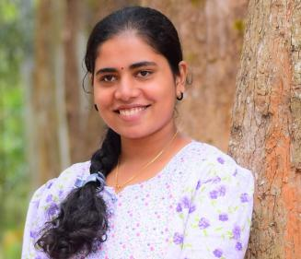

**Student in Charge: Ms Gayathri Santhosh**

**Gardening and field visits:**

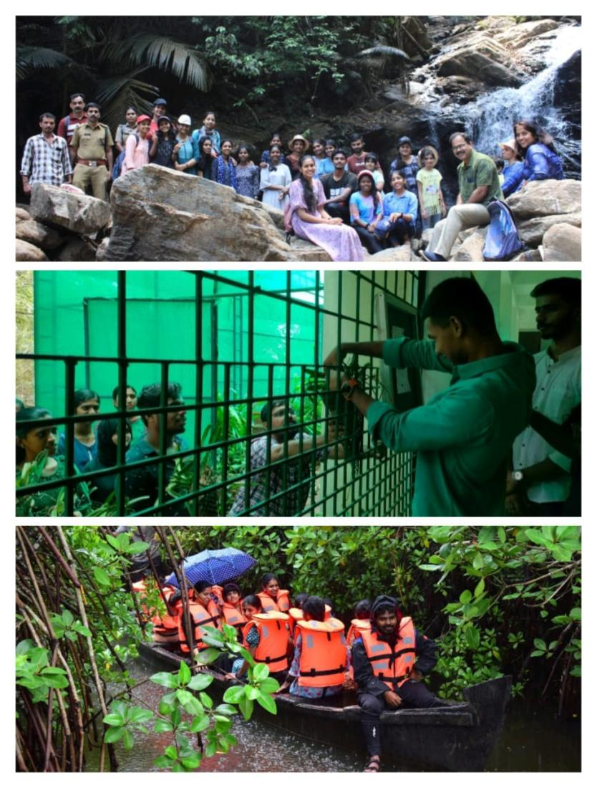

**Festival celebration:**

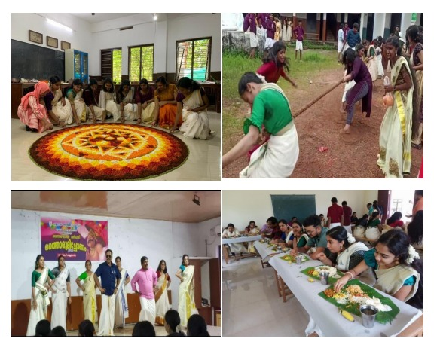

**Exhibitions and farewells:**

