**WINGS**

We in Need of Greater Space (WINGS) is a student club dedicated to promoting the welfare and inclusivity of differently abled students on campus. Recognizing the need for greater connectivity and support among disabled students, WINGS was established on March 15, 2023, under the guidance of the Equal Opportunity Cell of Payyanur College. The club aims to foster an inclusive atmosphere by organizing various programs, including inclusive tours, entertainment events, and awareness drives. These initiatives bridge the gap between disabled and non-disabled students, promoting mutual understanding and respect.

WINGS also observes National and International Days related to disability rights, keeping students informed about relevant opportunities, laws, and affairs. This creates a sense of community and awareness among students, encouraging them to support and advocate for inclusivity. Since its inception, the club has collaborated with regional organizations to further its social commitments, striving to bring positive changes. Through its efforts, WINGS seeks to create a supportive and inclusive environment that empowers differently abled students to reach their full potential. By promoting inclusivity and accessibility, the club aims to break down barriers and foster a sense of belonging among all students, regardless of their abilities.

Teacher-in-charge:

Mr Mani KP

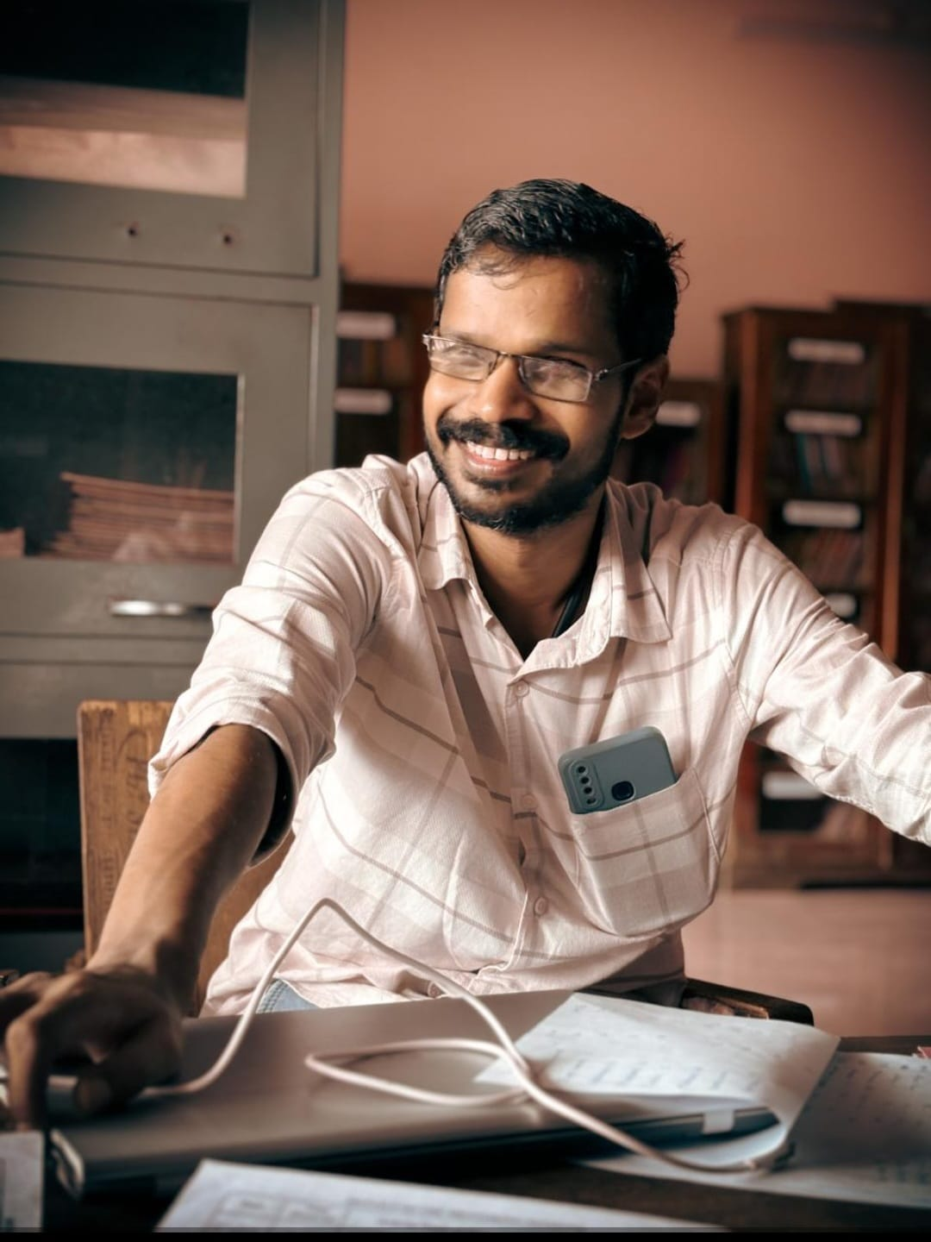

Student-in-charge: Nihad K

