**Tourism Club**

**Tourism Club Kerala** is the nodal agency formed by the Department of Tourism, Government of Kerala to nurture and develop young ambassadors of Kerala Tourism by forming clubs in colleges across the state. It will pave the way for new tourism trends and create interest in travel among students. Tourism in Kerala is going through a significant face of growth and development after the global pandemic of Covid 19. Youths are the assets of the nation and the most dynamic segment of the population in any country. Therefore it is essential to educate and elevate young minds towards the richness of tourism in a state like Kerala. It is to establish this idea that the Department of Tourism has decided to set up Tourism clubs in Kerala by collaborating with the State's Higher Education Department and moulding college students as ambassadors of Tourism.

Tourism Club mainly focuses on tourism promotion and development through the student community. The aim of the Tourism Club is "Capacity Building Through Responsible Service". Through these clubs, the youth can explore the endless possibilities and opportunities to improve not just their soft skills but apply their ideas to develop a responsible tourism network.

Tourism club not only uplifts the travel and hospitality sector but also helps expand the parameters of the student community in contributing to the tourism department of the state. It would help the students in imbibing a hands-on experience rather than asserting the theoretical definitions of developments. It would also help them in securing financial independence and become self-sufficient from a young age. The tourism clubs would be a rewarding experience for the student community as it develops their social interaction skills and expose them to limitless opportunities which would directly help them in framing their career and higher education.

To begin a unit of Tourism Club in our College we applied for the same on May 2023. For the approval of a Tourism Club in Colleges there are a few stages are there to complete. As the initial stage of registration we applied for it and our institution has been successfully completed it on 14th June 2023. There are three distinct roles in a Tourism Club in Colleges, Principal, Programme Manager, and Volunteer Conveners. The Programme Manager should be dedicated to the activities of the Tourism Club. Dr Arun Thomas M., Assistant Professor, Department of History, selected as Programme Manager of Tourism Club in our institution. After that the head of the institution and the Programme Manager selected volunteer conveners (both male and female) who will actively assist in coordinating club activities and events. Saithya Prakash, and Sooryathejas S., third year BA History students are selected as volunteer conveners of Club.

We need to select 50 club members from the students but it delayed because after the successful registration the authorities of Tourism Club in Kerala informed us that they will gave a training session for Programme Manager and Volunteer Conveners for the better performance in Tourism Club. But they delayed it for some reasons and we didn’t get the training. Because of that the activities of Tourism Club also get delayed.

**Programme Manager**

**Dr Arun Thomas M**

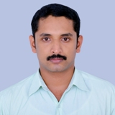

**Volunteer Conveners 1**

**Sooryathejas S**

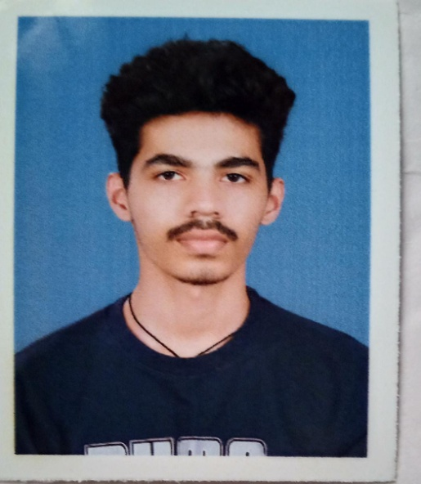

**Volunteer Conveners 2**

**Saithya Prakash**

