***“Humanity’s greatest advances are not in its discoveries, but in how those discoveries are applied to reduce inequity.”***

The Department of Management Studies inaugurated the Rural Entrepreneurship Club on 24/09/2020. The primary goal of this club is to create a vibrant entrepreneurial involvement among students which compliments their academic learning by developing essential entrepreneurial skills such as leadership, problem solving and innovation. Our college is recognized as a member of the National Rural Entrepreneurship Mission. We have conducted various programmes in collaboration with Mahatma Gandhi National Council for Rural Education and other college level activities in order to promote various aspects of entrepreneurship.

**Members of the Club**

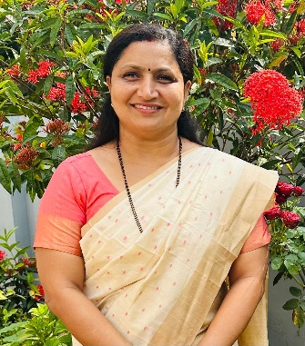

Archana Kemanabally

Faculty Coordinator



Dr. Vigi V Nair

Head of Department



Thushar K V

Student Coordinator

**GALLERY**

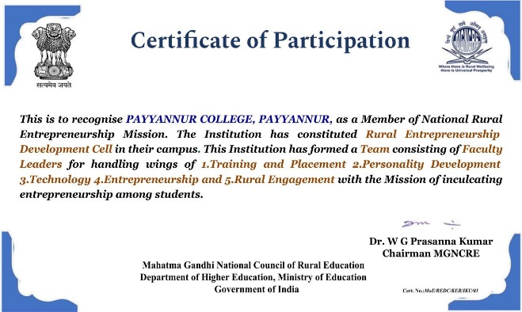 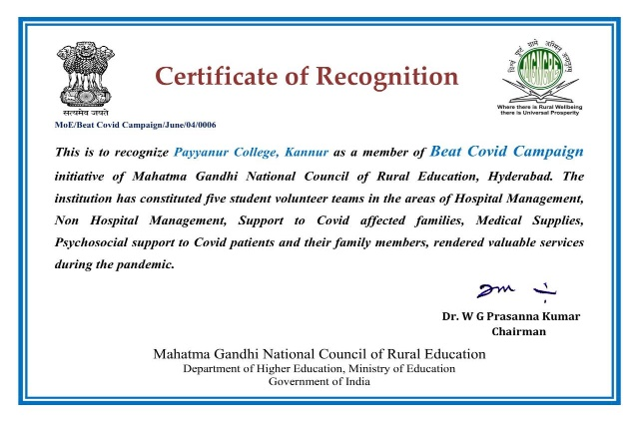

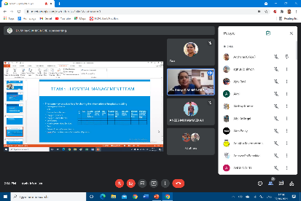 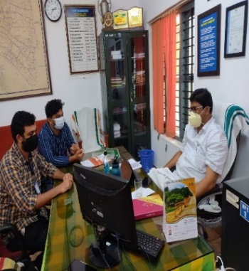 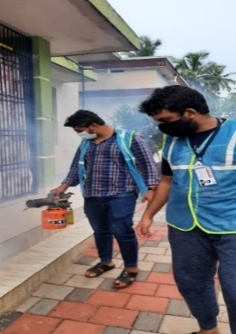

***Inauguration*** ***Beat Covid Campaign-Online Community Connect***

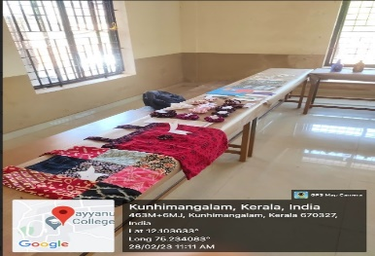 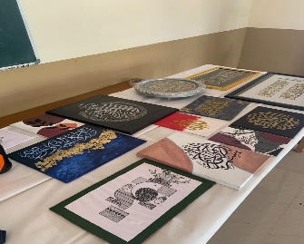 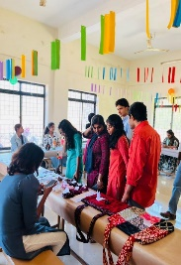 

***Skill Development Initiative*** **- OPUS**