**FORUM FOR DEMOCRACY AND SOCIAL JUSTICE (FDSJ)**

The Institute of Parliamentary Affairs (INPA) is an autonomous institution of the Government of Kerala. It was established to strengthen parliamentary democracy and foster a sense of democratic citizenship among people. INPA carries out various activities to make democracy the organising principle of social and political life in India.

The Forum for Democracy and Social Justice (FDSJ) is an initiative by INPA to instill democratic values and principles in students. The goal of FDSJ is to deepen the roots of parliamentary democracy by raising awareness of responsible citizenship and democratic values among young people. This helps them effectively contribute to strengthening parliamentary democracy in India.

The Forum for Democracy and Social Justice (FDJS) was established at Payyanur College during the 2022-2023 academic year as directed by the Kerala Government. The main objectives of the Forum are to promote democratic values and human rights among students through various programs. Since its formation, FDJS at Payyanur College has conducted three programs.

Teacher in Charge: Dr Sudheesh K M



Student Co-ordinator: Aswin Dev



**Constitutional Day Celebrated on 26th November 2022**

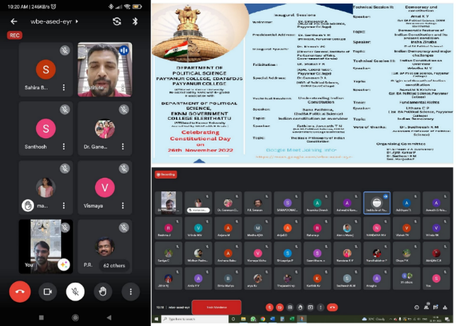

**National Girl Child Day Observation on 24/01/2024**

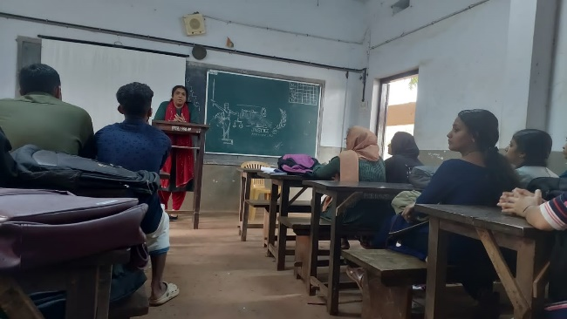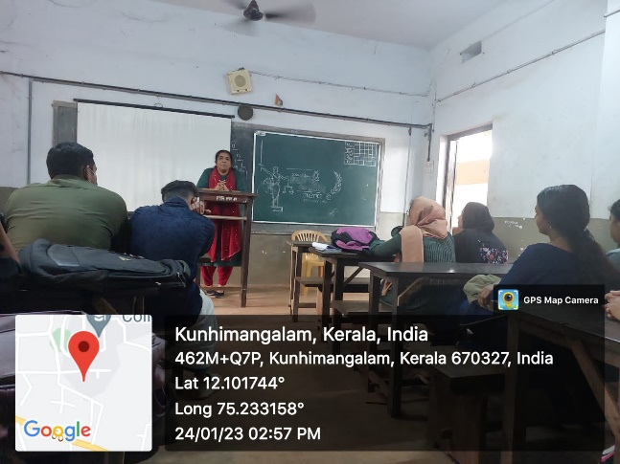

**Republic Day Celebration 26/01/2024**

