**HISTORY CLUB**

History Club is associated with the Department of History, Payyanur College, Payyanur, commmence in 2018 for students to engage with historical studies beyond the classroom. Club membership is typically open to all students of History Department. History clubs aim to create awareness among students about significant historical events and days. The Club engaged students in various activities that promote an understanding of historical events and themes while fostering community involvement. The Club arranged field visits to historical monuments and sites in nearby localities, allowing students to experience history in firsthand. These trips are designed to enhance students' appreciation for historical preservation and cultural heritage. Both teachers and students actively participated in the Club activities.

Dr Arun Thomas M., is presently the staff Coordinator and Febha Anil is student Coordinator of Club.

**Staff Coordinator**

**Dr Arun Thomas M**

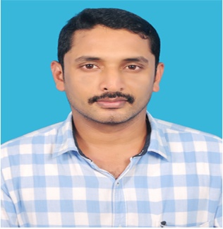

**Students Coordinator**

**Ms Febha Anil**



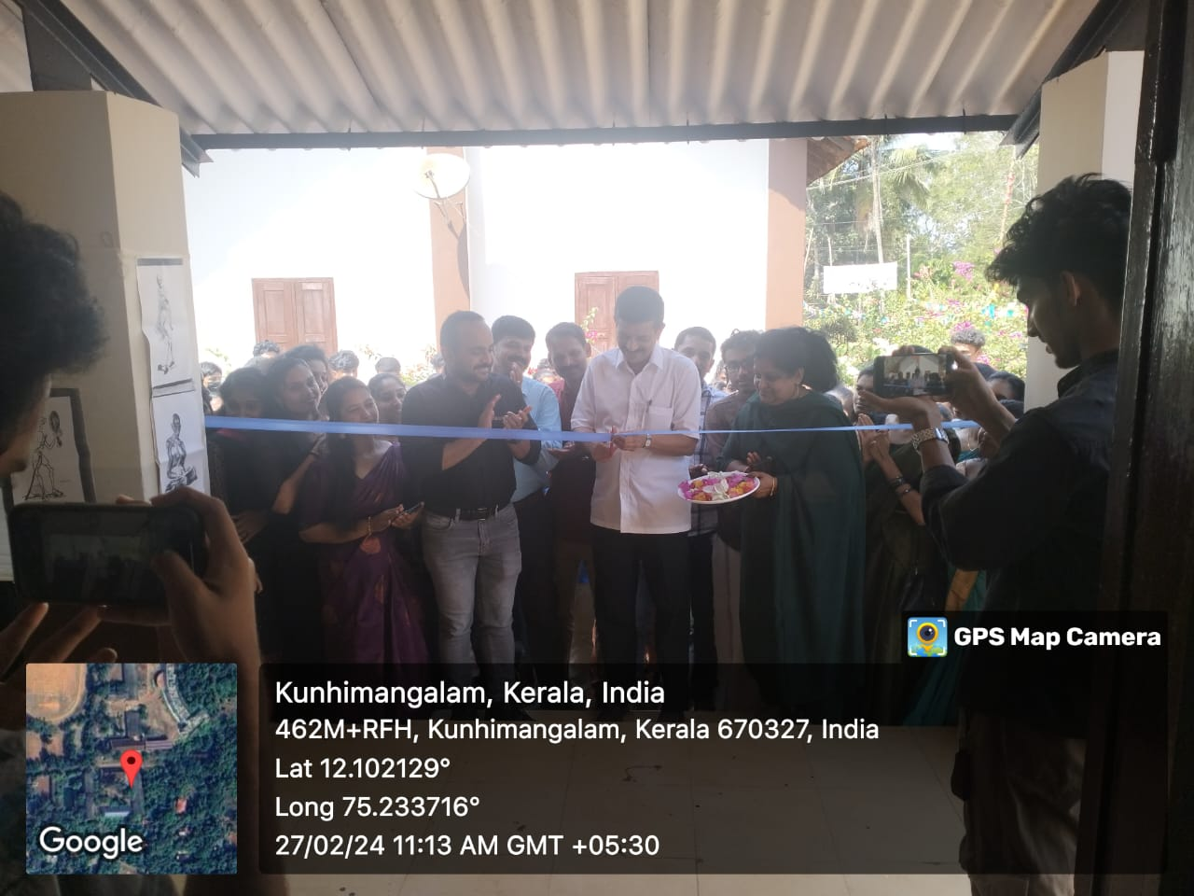

‘Le Passe’ Inauguration (History Club Activity organized on 24 February 2024)

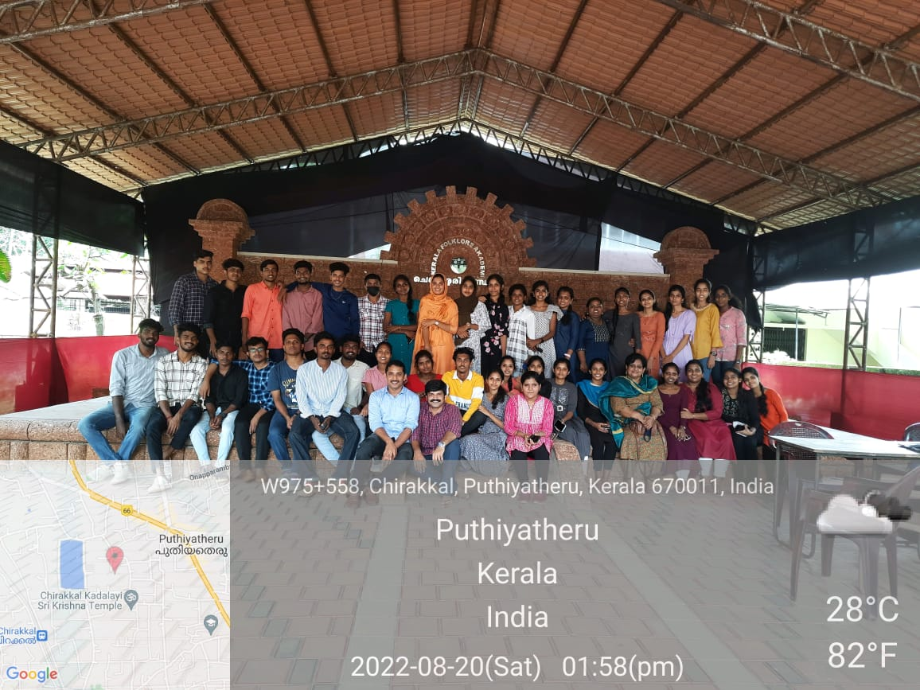

Field Visit at Folklore Academy on 20 August 2022