The Hindi department of Payyanur College has formed various clubs to nurture the creative talents of students and to introduce them to the depths of literature. One such club is the 'Recitation Club', which endeavours to explore various aspects of poetry, understand poems from different eras, and analyse them from multiple perspectives.

Every year, the college conducts poetry recitation competitions at the school and college levels. Under the guidance of a teacher from the Hindi department, a student with an interest in Hindi is also included in the organizing team each year. This helps to cultivate the students' interest in literature to some extent.

It is a notable achievement for the Hindi department of Payyanur College that they are able to conduct such activities every year.

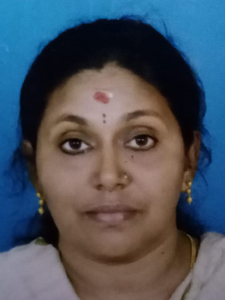Dr. Mini A R

Sapna Gupta

Programmes conducted   
