HINDI SAHITYA MANCH

The Hindi Sahitya Manch in department of Hindi, Payyanur college, Payyanur is a very vibrant and dynamic plat form for our students to perform their creativity and various programs over and above their regular academic curriculum. The Sahitya Manch was functioned with a view of developing and improving their language skills, in-born talents and the various interests that enables students to articulate their ideas in a better way which help to mould them for a better future in the modern competitive world.

The Hindi Sahitya Manch celebrates various activities like literary events, discussions, concerts and debates to develop the interpersonal skills among our students. Sahitya Manch Organizes various competitions like Quiz Programs , Essay Writing, story writing and elocution etc. for our students. They would be able to overcome stage fright and low self confidence through such competitions. Sahitya Manch also celebrates special day like Hindi Diwas, Vishwa Hindi Diwas, international reading day, Premchand Jayanthi and Nirala Jayanthi etc and in this manner students will understand the significance of such events. All these programs are student centric ongoing program. Sahitya Manch encourage students to read different types of books and share their reviews. Students have access to a whole world of opportunities through literary works and it fosters the creative and analytical skills of the students which improve their communication skills.

Communication skills are essential for students to thrive in any field of work. When they acquire the ability to communicate effectively they feel confident.

Teacher in charge:

Dr. Sreemaya C

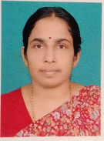

Student In Charge:

Mr. Vishnu Rajeeven

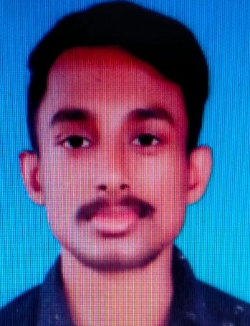

NATIONAL HINDI DAY CELEBRATION

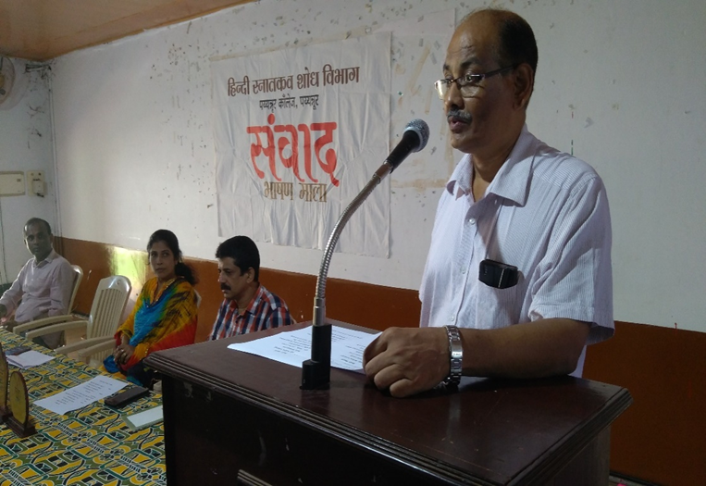

PREMCHAND JAYANTHI CLEBRATION

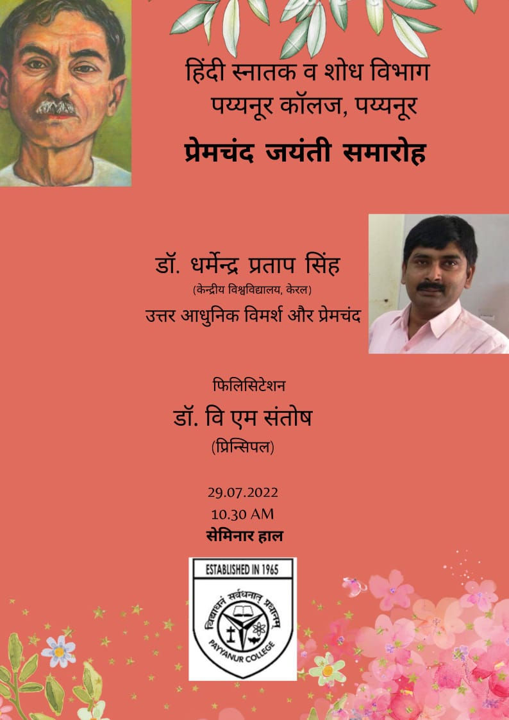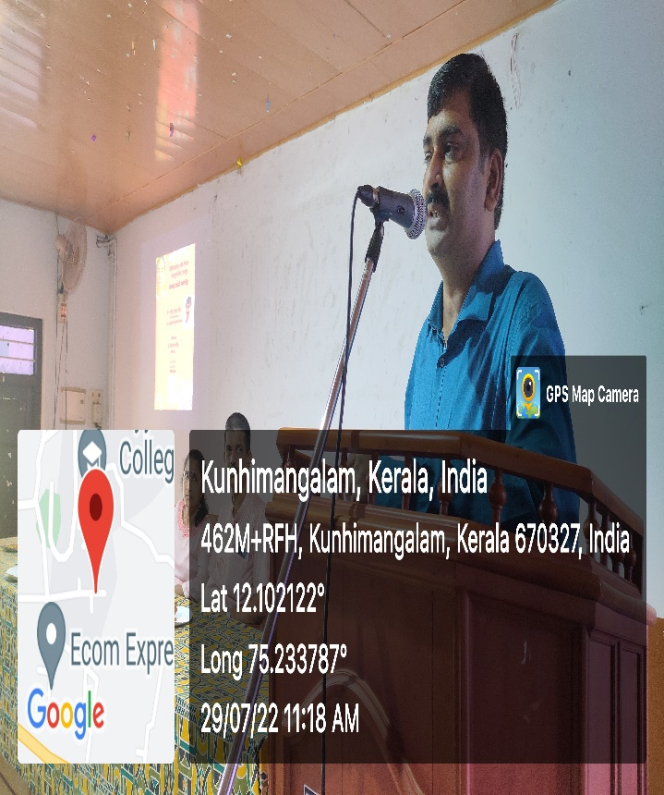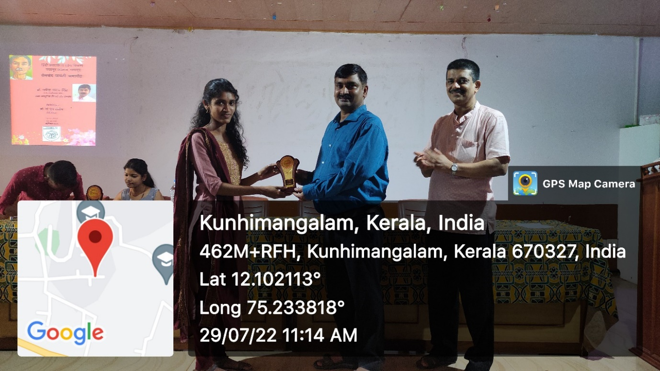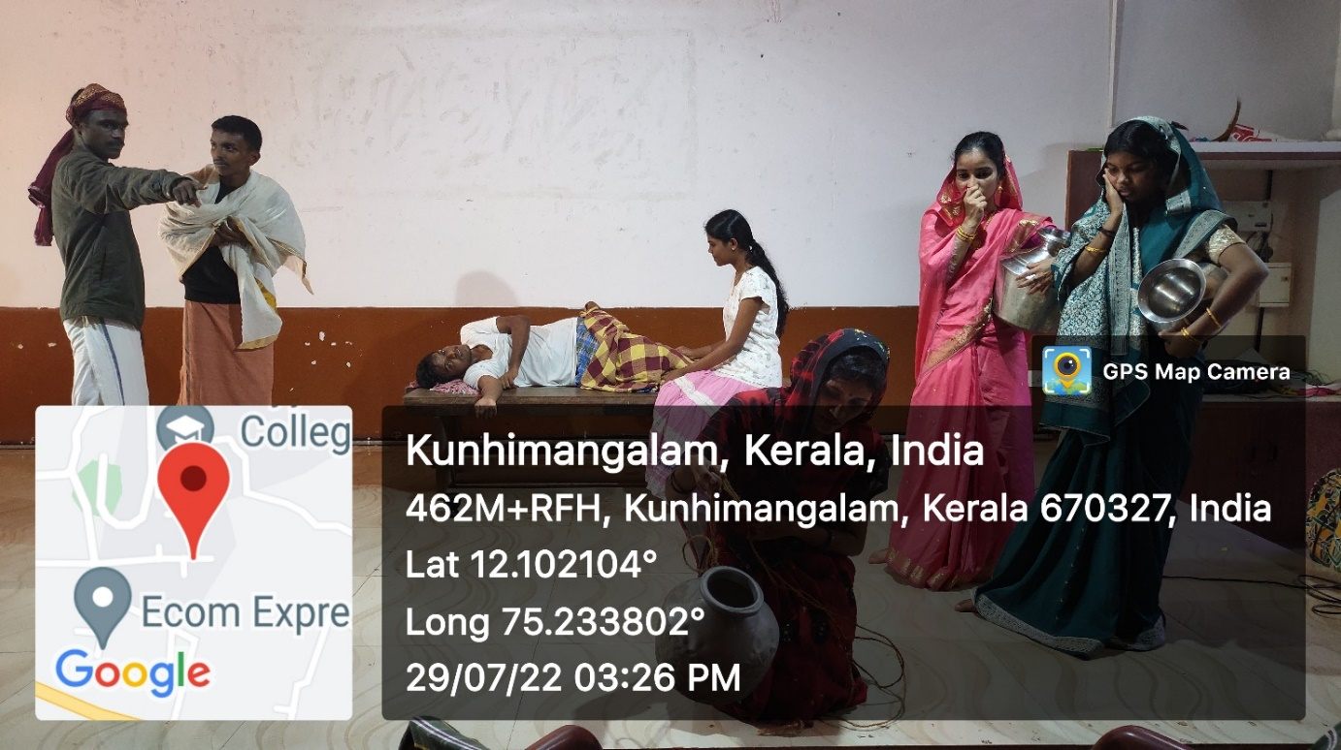

Premchand Story “Takur Ka Kua” portrayed as a Play by the Students of the Department