**ELECTORAL LITERACY CLUB**

The Electoral Literacy Club (ELC) of Payyanur College, Payyanur functions as per government directives to educate new voters aged 18-21 about election ethics, voter registration, and constitutional obligations. By strongly upholding the dictums, ‘Every vote counts’ and ‘No voter is to be left behind,’ the club promotes understanding of EVM and VVPAT systems and encourages ethical voting practices through activities that introduce students to the electoral system and impart exclusive learning, helping them become prospective and empowered voters. Each year, a faculty and a student coordinator, appointed by the Principal, ensure the club’s effective functioning, with membership lasting through graduation. The ELC engages in innovative initiatives such as voter awareness campaigns, assisting in voter registration, and conducting debates, surveys, and lectures on electoral topics. The ELC ensures inclusivity, supporting underprivileged and differently-abled students, and collaborates with local bodies and NSS units to enhance voter participation. The college website provides resources for voter registration, and ongoing efforts aim to enroll all eligible students as voters, with a significant number already registered. The link to the National Voters Service Portal (https://voters.eci.gov.in/) is provided on the college website for the convenience of students.

Staff Coordinator of 2023-24: Dr. Sreehari A.C., Member of Payyanur College Council.

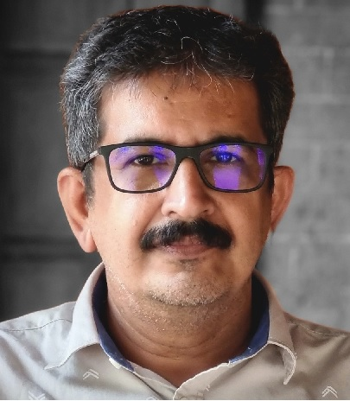

Student Coordinator of 2023-24: Nandana P., Member of Payyanur College Students Union. 

