**DEPARTMENT OF COMMERCE**

**ENTREPRENUERSHIP DEVELOPMENT CLUB (ED CLUB)**

The ED Club, a registered entity with the District Industrial Centre (DIC), aims to inspire and motivate second-year commerce students to embrace entrepreneurship. The club's membership consists of enthusiastic students who are eager to learn and explore the world of business.

Through various initiatives, such as entrepreneurship awareness programs, industrial visits, and interactive sessions, the ED Club fosters a culture of innovation and enterprise. One of its notable endeavours is the publication of the magazine "Leaders Speak," which features interviews with accomplished entrepreneurs.

Student members form groups and conduct in-depth interviews with selected business leaders, compiling their findings into a comprehensive report. These reports are then curated into the magazine, offering a unique platform for students to learn from the experiences and insights of successful entrepreneurs."

Faculty Co-Ordinator Student Co-Ordinator

Krishna Nambiar (Assistant Professor)

(As

Anurag Gokul M P(II B Com)



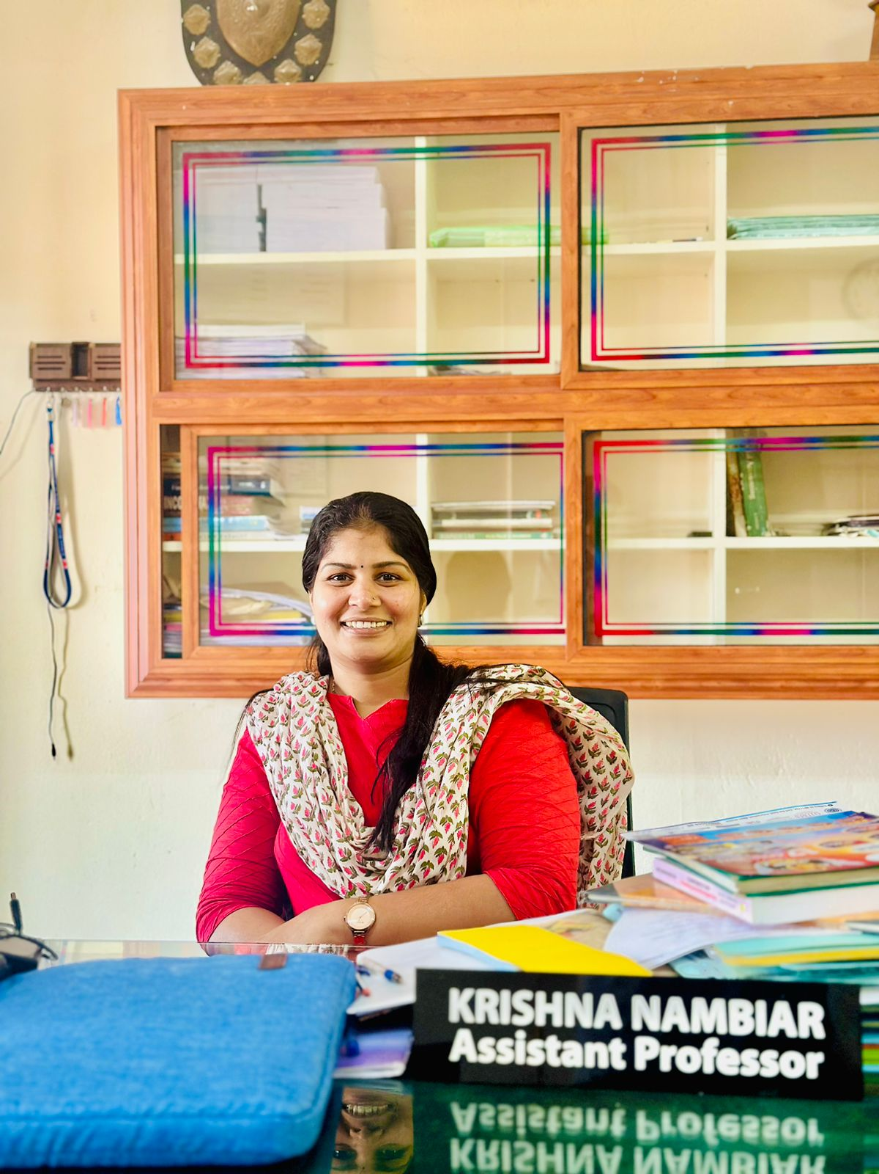

Activities

“Leaders Speak Magazine”

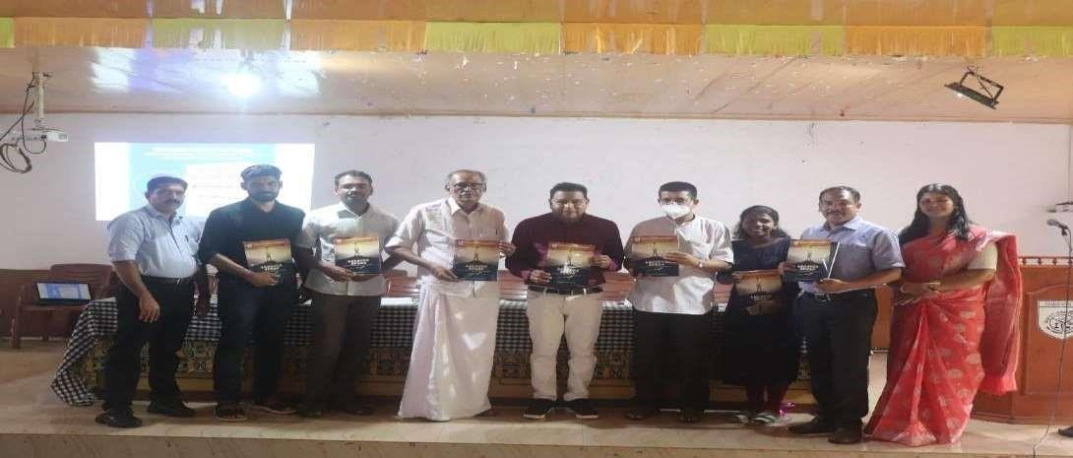 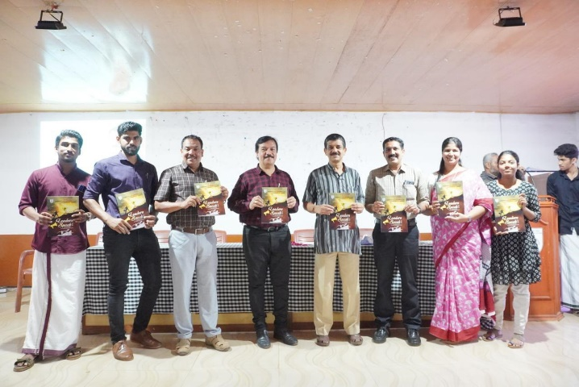

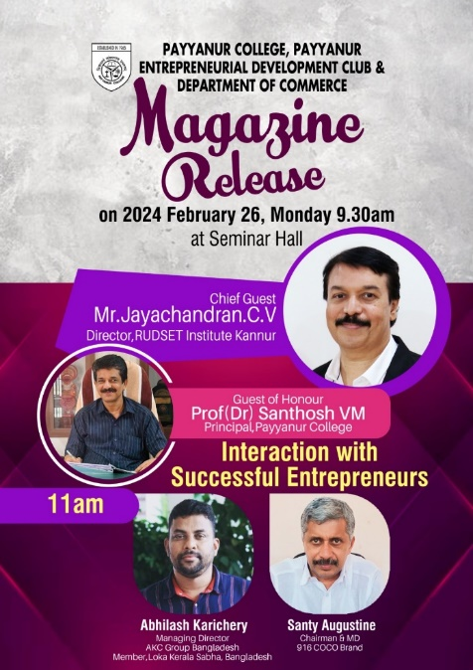

Industrial Visits

