**Welcome to the Astronomy Club**

The Astronomy Club is a vibrant community of students, faculty, and staff in the Department of Physics who share a passion for exploring the wonders of the universe. Our mission is to foster a deeper understanding and appreciation of astronomy and astrophysics through:

- Regular stargazing sessions and observation nights

- Guest lectures and workshops by experts in the field

- Discussions and debates on latest astronomical discoveries and research

- Hands-on activities and projects, such as telescope building and astrophotography

- Outreach and education programs to share the excitement of astronomy with the wider community

*Our Goals:*

- To provide a platform for students to explore their interests in astronomy and astrophysics beyond the classroom

- To promote interdisciplinary learning and collaboration among students from diverse backgrounds

- To foster critical thinking, problem-solving, and creativity through hands-on astronomical activities

- To build a community of astronomy enthusiasts who can learn from and inspire each other

Join Us!

Whether you're a seasoned astronomer or just curious about the night sky, we invite you to join our club and be a part of this exciting journey of discovery and exploration!

Teacher in charge: Dr. Reshmi. P.M.



Student in Charge: Hridya .P. , II DC Physics



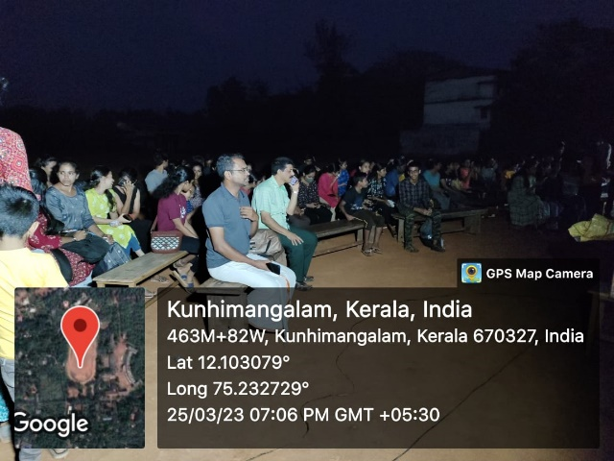

ORION NIGHT SKY WATCH 2023