ACTIVITIES OF THE ACADEMIC YEAR 2019-20
3 March 2020
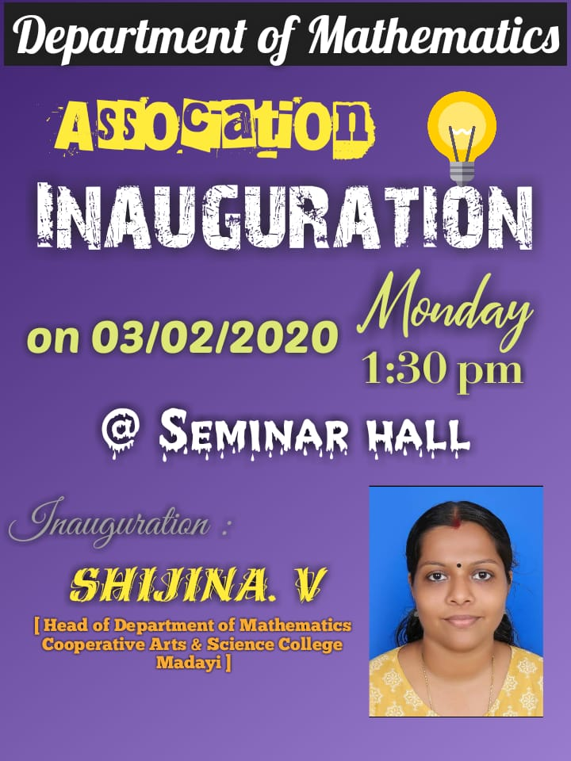
Dr Shijina V, Assistant Professor and HoD of Mathematics, Cooperative Arts &Science College, Madayi had inaugurated the activities of Mathematics Association and delivered a lecture on the topic ‘Introduction to Fuzzy Sets’ on 03rd February 2020 and the University Rank holders (Sunaiba A – Second position in Kannur University MSc Mathematics Examination April 2019 and Suhaira C H – Third position in Kannur University BSc Mathematics Examination April 2019) were felicitated on the same occasion.
MATHEMATICS ASSOCIATION INAGURATION OF ACADEMIC YEAR 2019-20
Dr. SHIJINA V, COOPERATIVE ARTS &SCIENCE COLLEGE, MADAYI
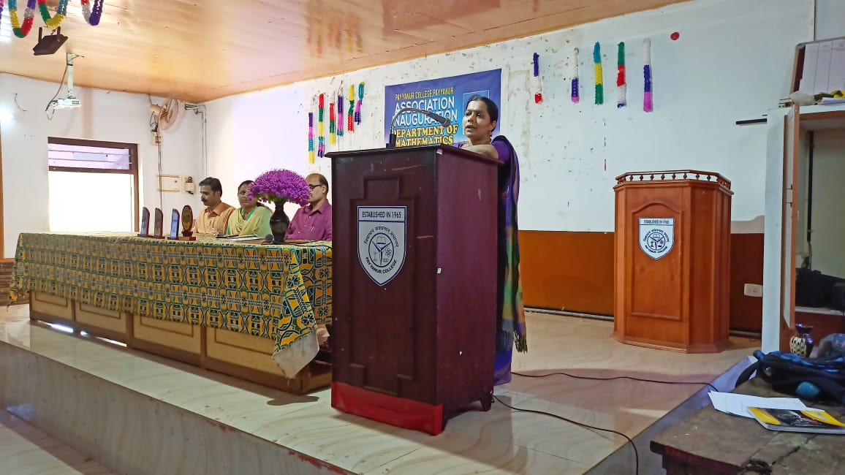
FELICITATION TO UNIVERSITY RANK HOLDERS
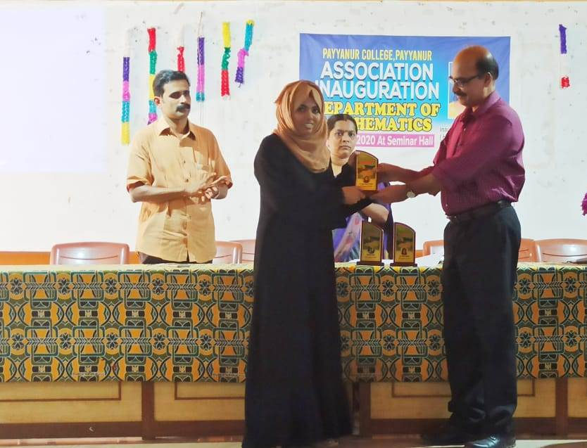

Talk by Dr Shijina V on “ Introduction to Fuzzy Sets”
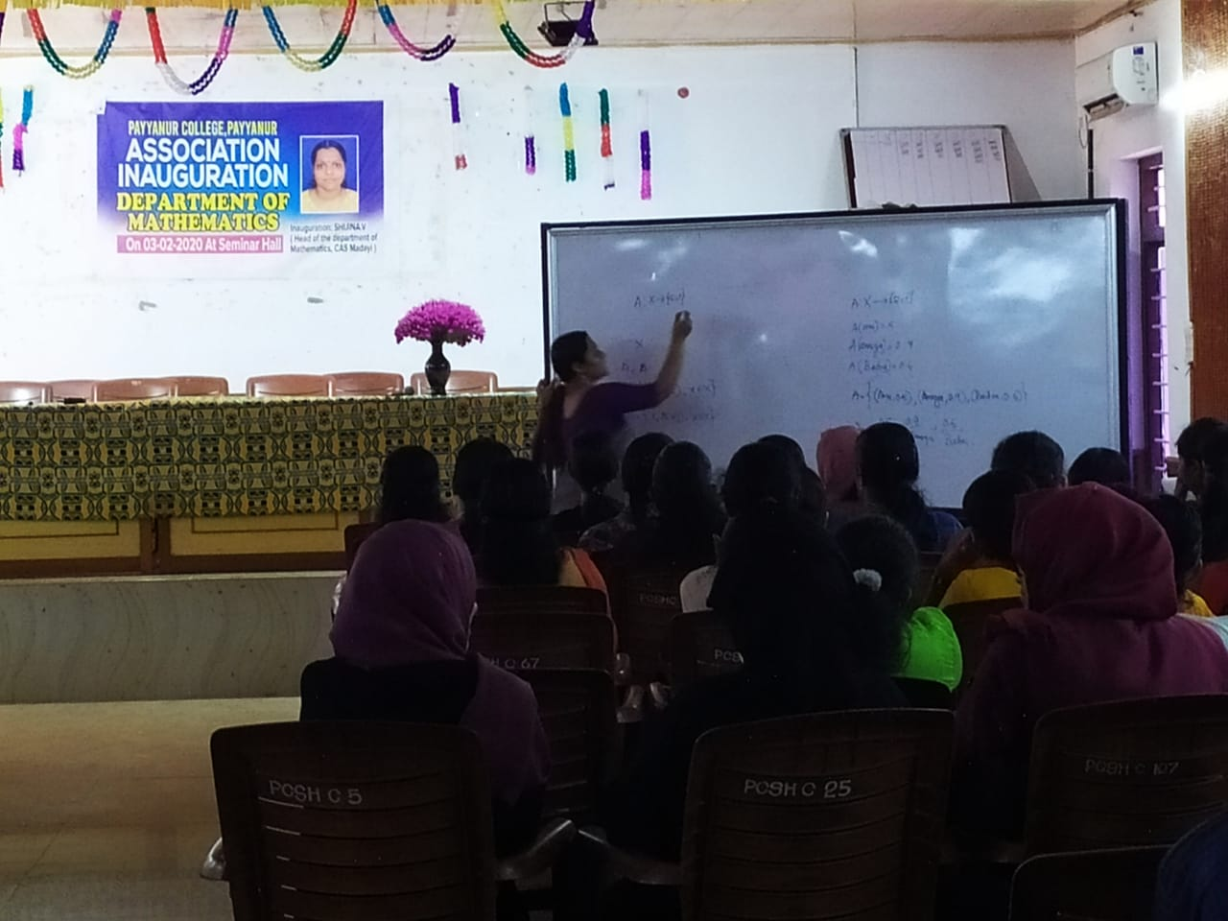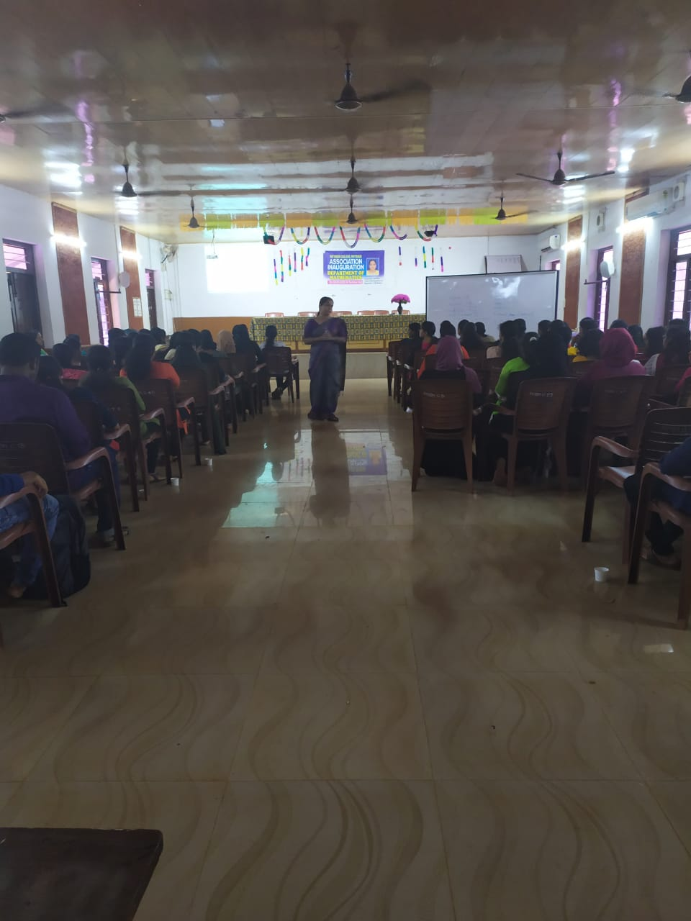

April- May 2020

An online course for solving previous CSIR-NET Questions was conducted for Candidates under Kannur University Region during summer vecation
