Research Centre: **Department of Mathematics, Payyanur College, Payyanur**

Date of Recognition of Research Centre: **20-11-2005**

**Research Guides**

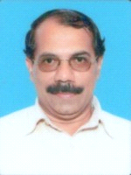

**Dr K T Ravindran**

**(**Retired on 31-05-2018**)**

Date of change of center of research guidance from university Central library to Department of Mathematics Payyanur College: **06-03-2006**

At Present: **Principal,**

College of Applied Science, Cheemeni

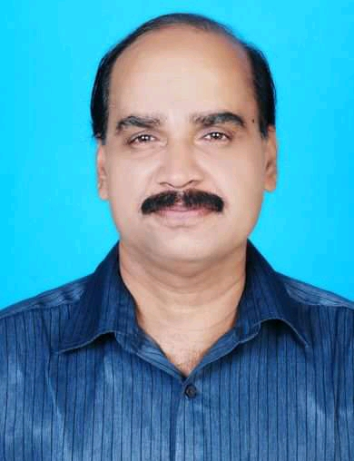

**Dr P C Sreenivas**

**(**Retired on 31-03-2020**)**

Date of Recognition**: 02-01-2013**

At Present: **Principal**

Gurudev Arts &Science College, Mathil

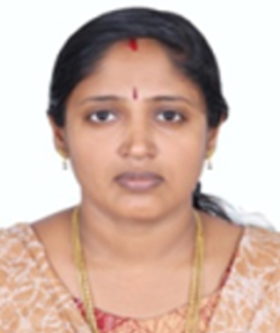

**Dr Reeja P V**

Date of Recognition**: 02-09-2022**

At Present: Assistant Professor

Department of Mathematics

Nehru Arts & Science College,

Kanhagad

**Ph. D Awardees**

Name:**Dr** **Anoop S K**

Guide: **Dr K T Ravindran**

Title: **Some Studies on Fixed Points of Non-Expansive Type Maps in Banach Spaces**

Year of award of Ph. d: **2012**

### Present Position: HSST, Gov. Higher Secondary

School

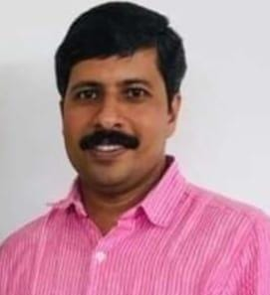



Name: **Dr Reeja P V**

Guide: **Dr K T Ravindran**

Title: **On L-Embedded Banach Spaces and its consequences in generalized 2 normed spaces**

Year of award of Ph. d: **2012**

Present Position: **Assistant Professor**

Nehru Arts & Science College,

Kanhagad

School

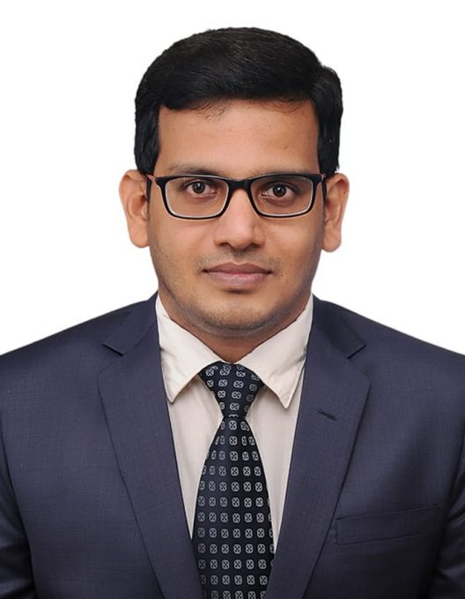

Name: **Dr Harikrishnan P K**

Guide: **Dr K T Ravindran**

Centre change date- 24-04-2013

Title: **Some aspects of Accretive and other operators in other abstract spaces**

Year of award of Ph. d: **2013**

### Present Position: Associate Professor-Senior Scale, Manipal Institute of Technology.

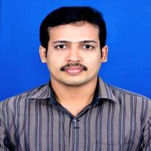

Name: **Dr Riyas P**

Guide: **Dr K T Ravindran**

Title: **Some characteristics of 2-Innerproduct space and 2-Normed spaces**

Year of award of Ph. d: **2015**

Present Position: **Assistant Professor**

Govt Brennen College,

Thalassery

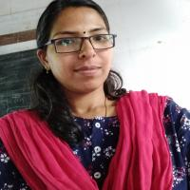

Name: **Dr Sunitha M**

Guide: **Dr P C Sreenivas**

Title: **A Study on I- Functions**

Year of award of Ph. d: **2021**

Present Position: **Assistant Professor**

Govt Brennen College,

Thalassery

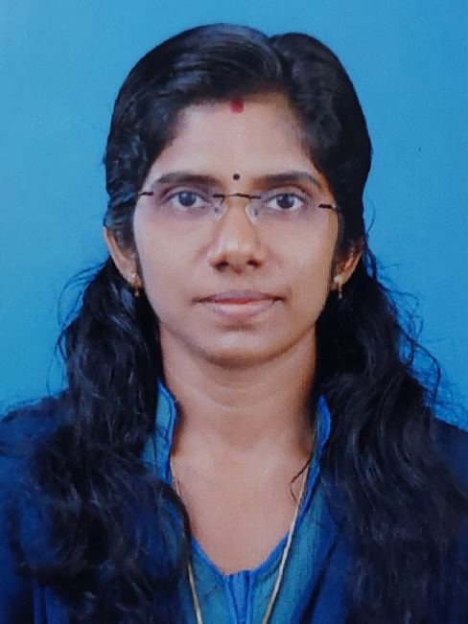

Name: **Dr Sithara Ramesan**

Guide: **Dr K T Ravindran**

Title: **On the study of some properties of Frames**

Year of award of Ph. d: **2021**

Present Position: **Assistant Professor (On Contract)**

Department of Mathematical Science

Mangattuparamba Campus

Kannur University